**PROJECT REPORT**

|  |  |
| --- | --- |
| Team ID | PNT2022TMID18438 |
| Project Name | Global Sales Data Analytics |
| Team  Members | Neathra V S  Nivetha G R  Priya V  Nandhini S |

1. **INTRODUCTION** 
   1. Project Overview
   2. Purpose
2. **LITERATURE SURVEY**
   1. Existing problem
   2. References
   3. Problem Statement Definition
3. **IDEATION & PROPOSED SOLUTION**
   1. Empathy Map Canvas
   2. Ideation & Brainstorming
   3. Proposed Solution
   4. Problem Solution Fit
4. **REQUIREMENT ANALYSIS**
   1. Functional Requirements
   2. Non-functional Requirements
5. **PROJECT DESIGN**
   1. Data Flow Diagrams
   2. Solution & Technical Architecture
   3. User Stories
6. **PROJECT PLANNING & SCHEDULING**
   1. Sprint Planning & Estimation
   2. Sprint Delivery Schedule
   3. Reports from Jira

1. **CODING & SOLUTION**
   1. Feature 1
   2. Feature 2
   3. Feature 3
2. **TESTING**
   1. Test Cases
   2. User Acceptance Testing
   3. Model Performance Testing

1. **RESULTS**
2. **ADVANTAGES & DISADVANTAGES**
3. **CONCLUSION**
4. **FUTURE SCOPE**
5. **APPENDIX**
   1. Source Code
   2. Github & Project Demo Link

# 1. INTRODUCTION

## 1.1 Project Overview

Shopping online is currently the need of the hour. Because of this COVID, it is not easy to walk in a store randomly and buy anything you want. So, try to understand a few things like, Customer Analysis and Product Analysis of this Global Super Store. Global Sales covers all activities involved in selling a product or service to a consumer or business. It is important for sales and marketing teams to review their strategies and performance in order to make improvements. Understanding performance with sales data analytics helps sales and marketing teams to review their strategies and performance in order to make improvements. Sales analytics provides valuable information like Customer Analysis and Product Analysis to improve sales methodologies. Users create multiple analytical graphs/charts/Visualizations. One way to measure performance is with sales analytics.

## 1.2 Purpose

Global Sales covers all activities involved in selling a product or service to a consumer or business. It is important for sales and marketing teams to review their strategies and performance in order to make improvements. One way to measure performance is with sales analytics. Sales data analytics refers to the use of technology to collect and use sales data to identify actionable insights. It is used to identify, optimize, and increase sales. An efficient sales model that generates higher revenue for the business.

# 2. LITERATURE SURVEY

|  |  |  |  |  |  |
| --- | --- | --- | --- | --- | --- |
| **Title & Author(s)** | **Year** | **Technique** | | | **Findings** |
| Big Data Analytics and Deep  Learning Based Sentiment Analysis System for Sales Prediction - Khatiwada, Aamod and Kadariya, Pradeep and Agrahari, Sandip and Dhakal, Rabin. | 2019 | Big ana app comm | ldata  l | s (BDA) ions in e- ce. | Merits: Used to understand complex datasets in a matter of time with beautiful visual representations.  Demerits: Lack of security since large data processed simultaneously |
|  |
| COVID-19 pandemic in the new era of big data analytics: Methodological innovations and future research directions -  Sheng, Jie and AmankwahAmoah, Joseph and Khan, Zaheer and Wang, Xiaojun | 2021 | Descriptive and diagnostic analytics, Predictive analytics | | | Merits: By comparing with machine learning models,  we find that the proposed  model is superior to others. Demerits: The experiment only considers the features of the product and does not consider external influences, such as the impact of regulations on sales. It uses only small dataset. |
| Sales Forecasting Based on | 2020 | CatBoost algorithm. | | | Merits: The search stops |
| CatBoost - Jingyi Ding, Ziqing Chen. |  |  | | | when no improvements over the current best solution have been foun in 300 iterations.  Demerits: Dataset is    limited |
| Developing and Implementing Big  Data Analytics in Marketing - Dina Darwish | 2020 | Big data  s, R tool. | | | Merits: The proposed method is based similarity measurem  without complex tra    so that forecast ca  completed in a s time, and performs w - small |
|  |  |  | | | scale data Demerits:  The  experiment only conside the features of the  product and does not consider external influences, such as the impact of regulations on sales. It uses only small dataset. |
| Social media big data analytics for | 2020 | Definitional ig cs | | | Merits: Captured linearity |
| demand forecasting: development and case  implementation of an  innovative framework-Iftikhar,  Rehan and Khan, Mohammad  Saud |  | aspects of b data analyti  (BDA) in  ecommerce | | | and non linearity better than ARIMA and ARNN  gave the best result of  565  RMSE. Demerits: Hybrid Technique can fail if nonlinear model fails to capture residue patterns |

## 2.1 Existing problem

1. Lack of security since large data processed simultaneously
2. Hybrid Technique can fail if nonlinear model fails to capture residue patterns
3. The experiment only considers the features of the product and does not consider external influences, such as the impact of regulations on sales. It uses only small dataset.
4. Dataset is limited
5. The experiment only considers the features of the product and does not consider external

influences, such as the impact of regulations on sales. It uses only small dataset.

## 2.2 References

1. Big Data Analytics and Deep Learning Based Sentiment Analysis System for Sales Prediction - Khatiwada, Aamod and Kadariya, Pradeep and Agrahari, Sandip and Dhakal, Rabin.
2. COVID-19 pandemic in the new era of big data analytics: Methodological innovations and future research directions - Sheng, Jie and Amankwah-Amoah, Joseph and Khan, Zaheer and Wang, Xiaojun
3. Sales Forecasting Based on CatBoost - Jingyi Ding, Ziqing Chen.
4. 2020 2nd International Conference on Broadband Communications, Wireless Sensors and Powering (BCWSP)-Wisesa, Oryza and Adriansyah, Andi and Khalaf, Osamah Ibrahim.
5. Developing and Implementing Big Data Analytics in Marketing - Dina Darwish
6. Social media big data analytics for demand forecasting: development and case implementation of an innovative framework-Iftikhar, Rehan and Khan, Mohammad Saud

## 2.3 Problem Statement Definition

1. Structured data focuses on demographic data including name, age, gender, date of birth, address, and preferences, unstructured data includes clicks, likes, links, tweets, voices, etc.
2. The methodological innovations in studying big data analytics and. We provide insights on methods in descriptive/diagnostic, predictive and prescriptive analytics, and how they can be leveraged to study ‘black swan’ events such as the COVID-19-related global crisis.
3. It proposed a sales forecasting system based on CatBoosting. The algorithm is trained on the Walmart sales dataset, by far the largest dataset in this field. We performed effective feature engineering to boost prediction accuracy and speed.
4. The results of this analysis are expected to generate reliable, accurate and effective forecasting data, a valuable resource for sales predictions. It shows good accuracy in forecasting.
5. Companies take informative business decisions in different fields, such as, health care, banking, manufacturing, media and entertainment, education and transportation and many others.
6. Social media big data offers insights that can be used to make predictions of products' future demand and add value to the supply chain performance

**3. IDEATION & PROPOSED SOLUTION**

## 3.1 Empathy Map Canvas

An empathy map is a simple, easy-to-digest visual that captures knowledge about a user’s behaviors and attitudes. It is a useful tool to help teams better understand their users. Creating an effective solution requires understanding the true problem and the person who is experiencing it. The exercise of creating the map helps participants consider things from the user’s perspective along with his or her goals and challenges.

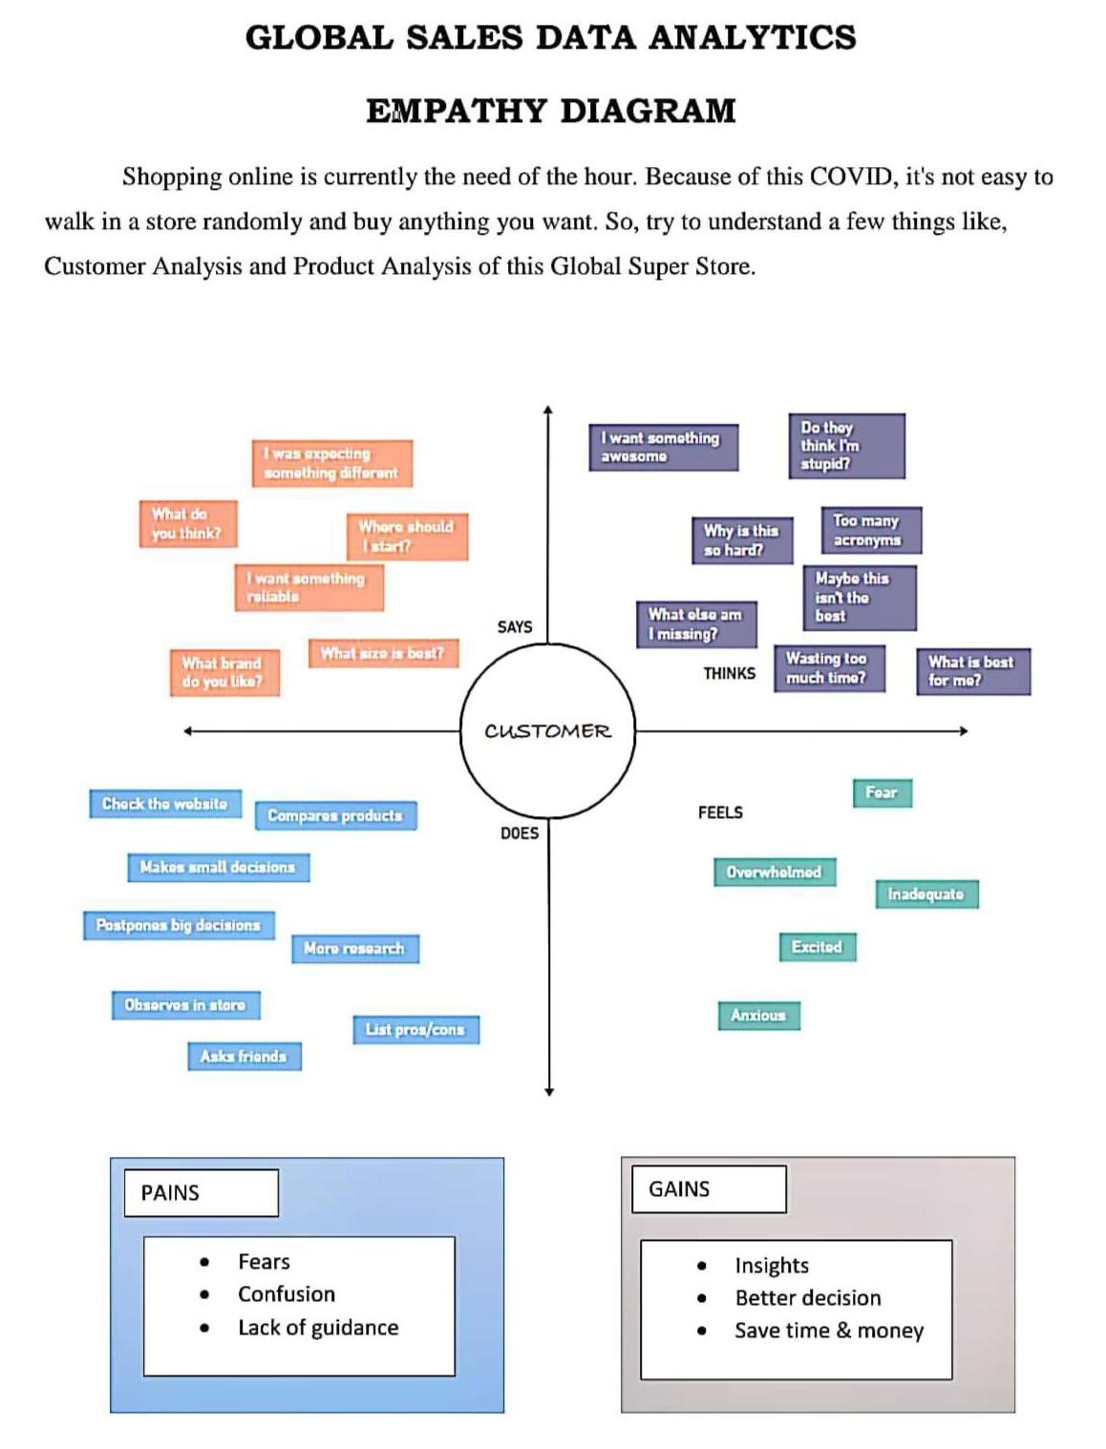

## 3.2 Ideation & Brainstorming

Brainstorming provides a free and open environment that encourages everyone within a team to participate in the creative thinking process that leads to problem solving. Prioritizing volume over value, out-of-the-box ideas are welcome and built upon, and all participants are encouraged to collaborate, helping each other develop a rich amount of creative solutions.

**Step-1: Team Gathering, Collaboration and Select the Problem Statement**

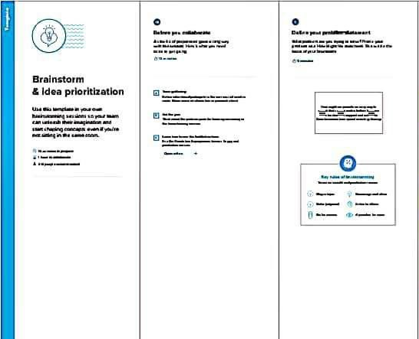

**Step-2: Brainstorm, Idea Listing and Grouping**

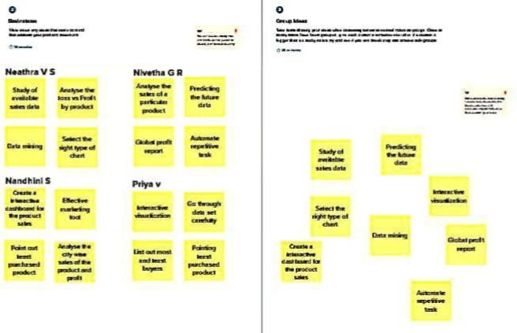

**Step-3: Idea Prioritization**

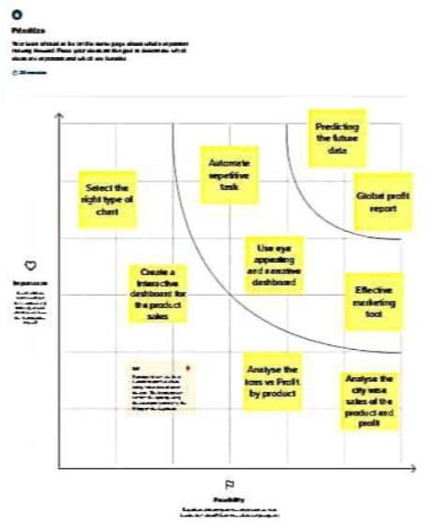

3.3 Proposed Solution

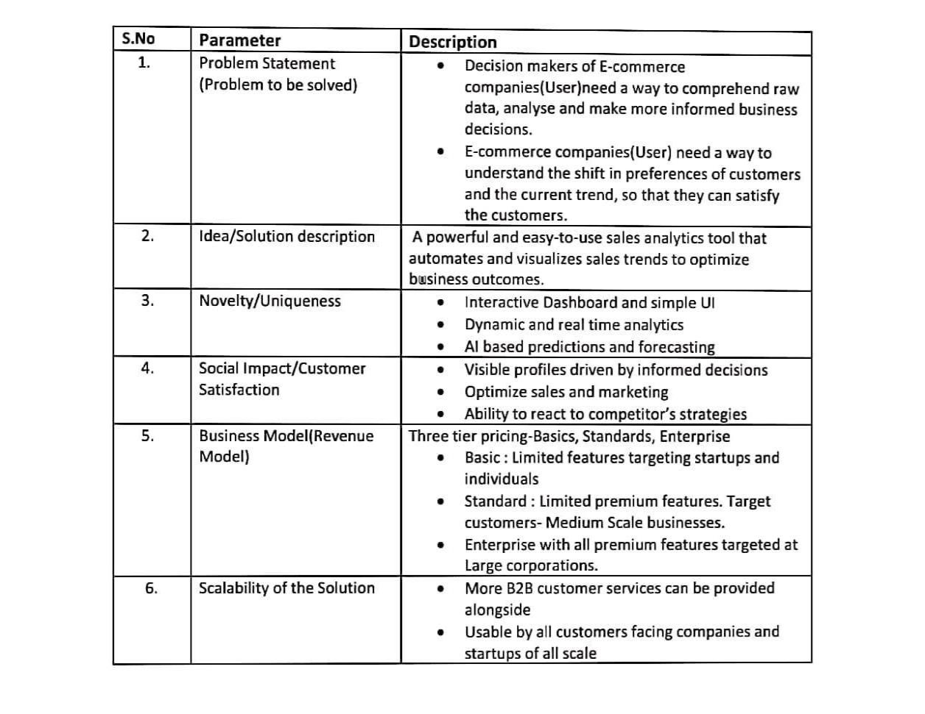

## 3.4 Problem Solution Fit

The problem solution fit simply means that you have found a problem with your customer and that the solution you have realized for it actually solves the customer’s problem. It helps to identify behavioral patterns and recognize on sales.

**Purpose:**

* Solve complex problems in a way that fits the state of your customers.
* Succeed faster and increase your solution adoption by tapping into existing mediums and channels of behavior.
* Sharpen your communication and marketing strategy with the right triggers and messaging.
* Increase touch-points with your company by finding the right problem-behavior fit and building trust by solving frequent annoyances, or urgent or costly problems.
* Understand the existing situation in order to improve it for your target group.

**Solution fit:**

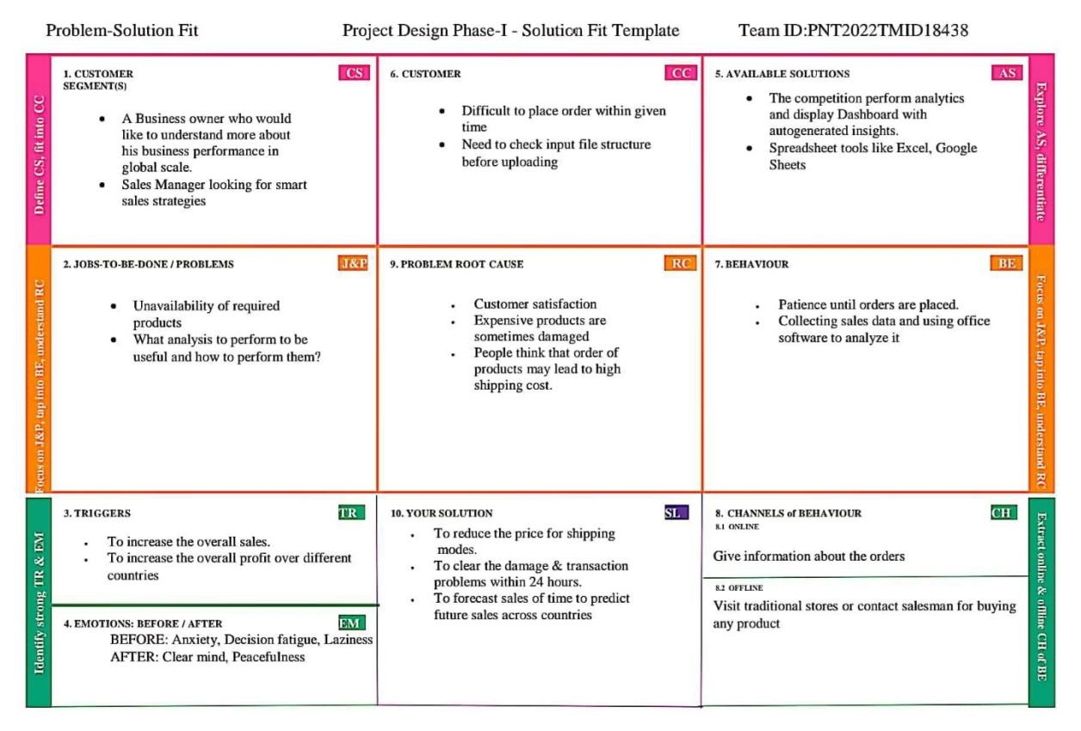

# 4. REQUIREMENT ANALYSIS

# 4.1 Functional Requirements

## 

|  |  |  |
| --- | --- | --- |
| **FR No.** | **Functional Requirement (Epic)** | **Sub Requirement (Story /**  **Sub-Task)** |
| FR-1 | User Registration | Registration through Website  Registration through Gmail |
| FR-2 | User Confirmation | Confirmation via Email |
| FR-3 | User Login | Login via Gmail and  Password |
| FR-4 | Generating  Report | User can view the product details |

## 4.2 Non-functional Requirements

|  |  |  |
| --- | --- | --- |
| **FR No.** | **Non-Functional Requirement** | **Description** |
| NFR-1 | Usability | This service will have a simple and user-fr  graphical interface. Use be able to understan  all the features easily. |
| NFR-2 | Security | The main security concern is for users login information is end to end encryption should be used to avoid hacking. |
| NFR-3 | Reliability | It has high reliability because when the system is disconnected or internet connection lost, it should save all the process of the users made. |
| NFR-4 | Performanc e | A good internet speed while browsing the product it had high performance with efficiency. |
| NFR-5 | Availability | It will be available 24 hours a day and seven days a week. User access anywhere at any time . |
| NFR-6 | Scalability | A Many users can access the website simultaneously. |

# 5. PROJECT DESIGN

## 5.1 Data Flow Diagrams

A Data Flow Diagram (DFD) is a traditional visual representation of the information flows within a system. A neat and clear DFD can depict the right amount of the system requirement graphically. It shows how data enters and leaves the system, what changes the information, and where data is stored.

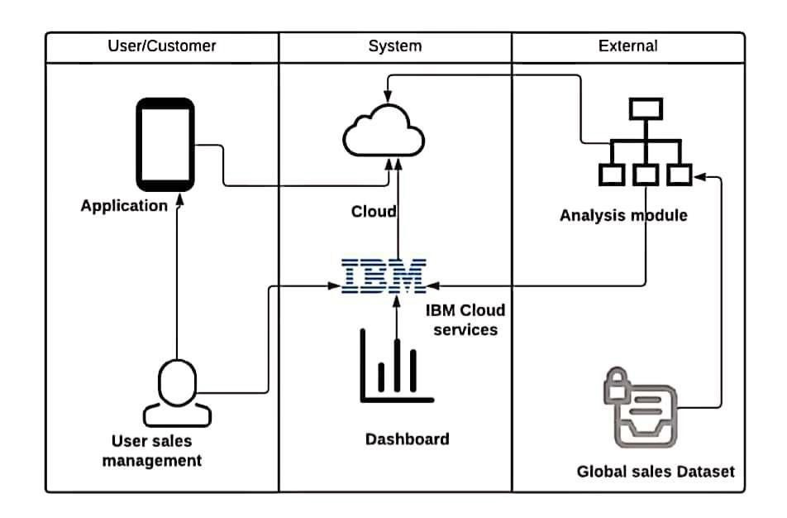

## 5.2 Solution & Technical Architecture

Solution architecture is a complex process – with many sub-processes – that bridges the gap between business problems and technology solutions. Its goals are to:

* Find the best tech solution to solve existing business problems.
* Describe the structure, characteristics, behavior, and other aspects of the software to project stakeholders.
* Define features, development phases, and solution requirements.
* Provide specifications according to which the solution is defined, managed, and delivered.

**Solution Architecture Diagram:**

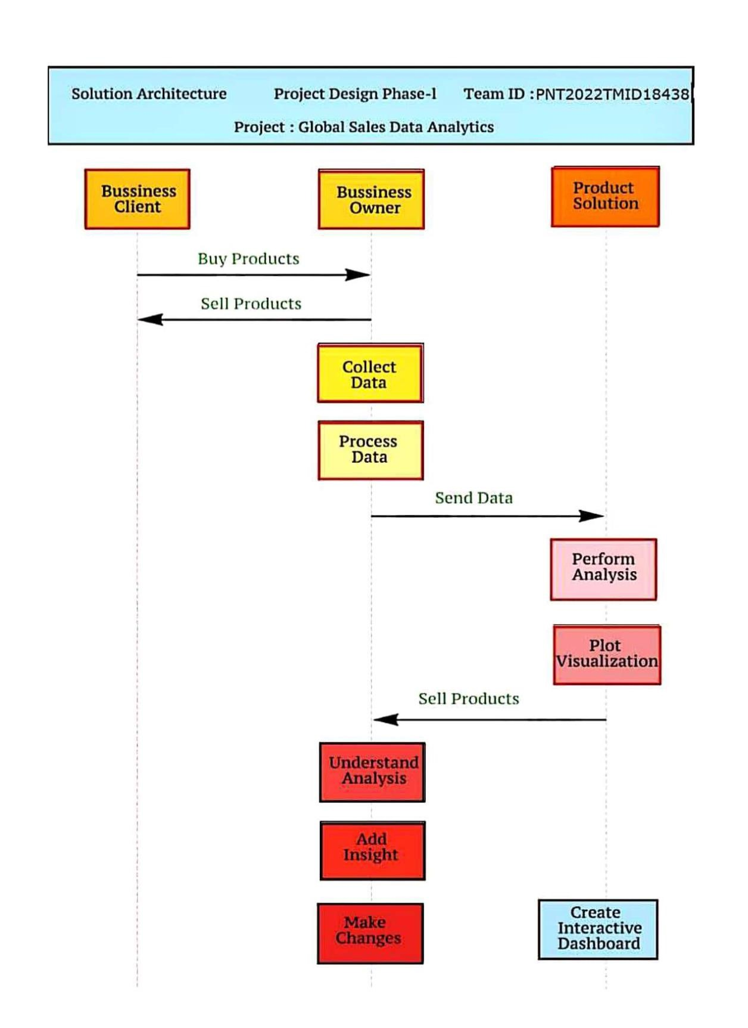

## 5.3 User Stories

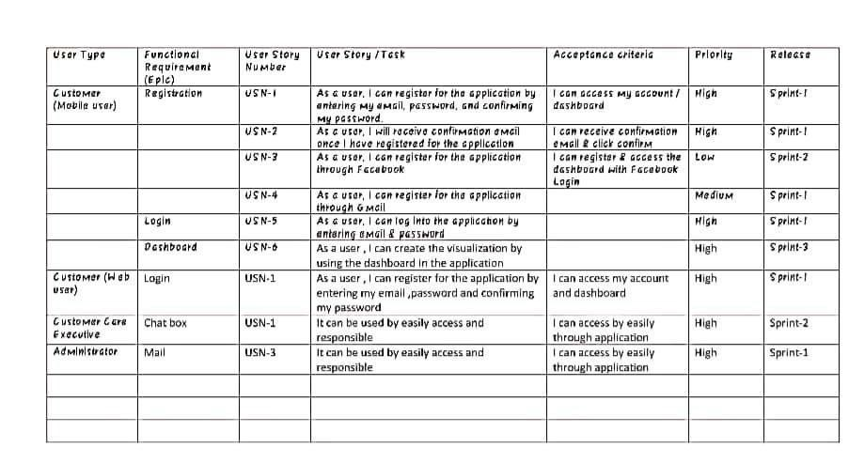

**6.PROJECT PLANNING & SCHEDULING**

## 6.1 Sprint Planning & Estimation



**6.2 Sprint Delivery Schedule**

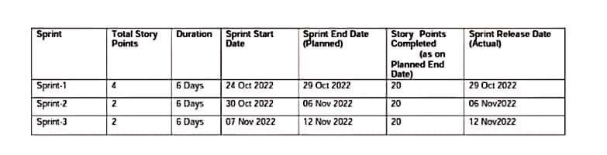

**6.3 Reports from Jira**

**ROADMAP**

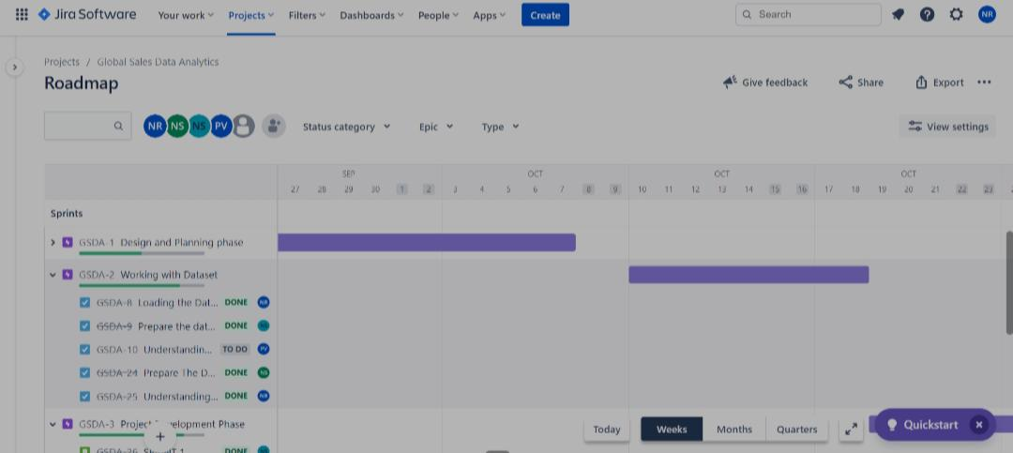

**SPRINT ACTIVITY**

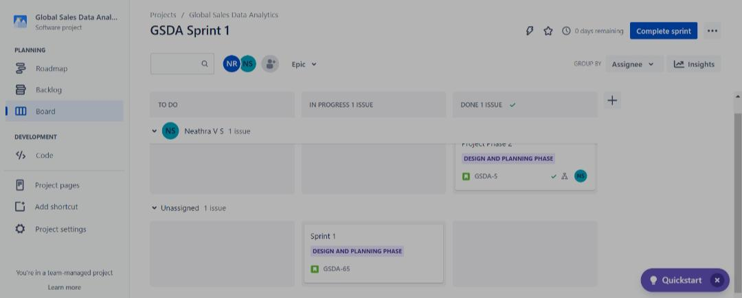

**SPRINT STATUS**

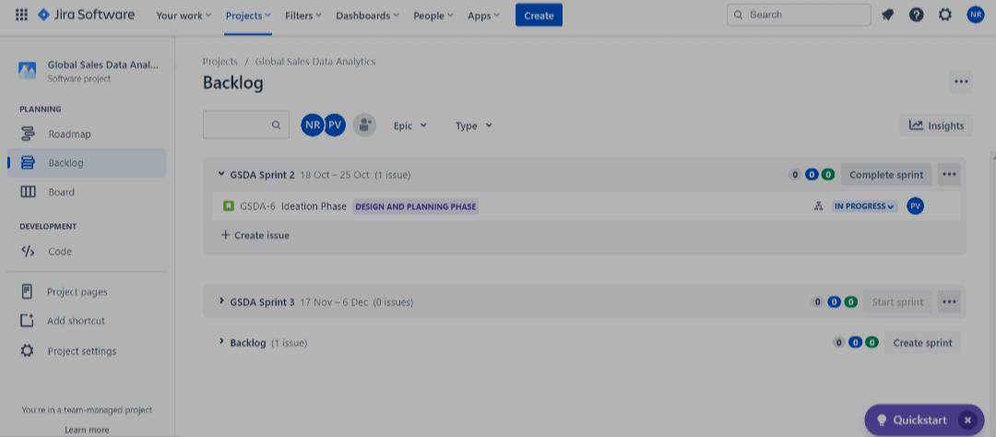

**BACKLOG**

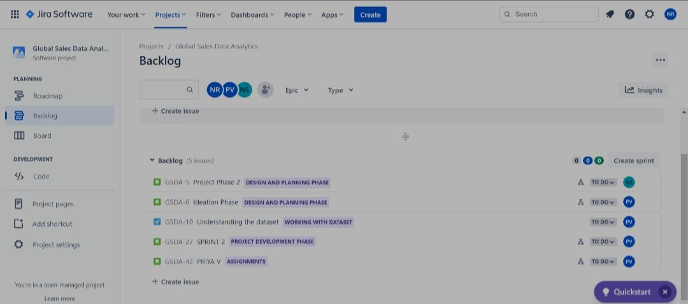

**7.CODING & SOLUTION**

**Feature 1 - Embedding dashboard to web app:**

<!DOCTYPE html>

<html lang=”en”>

<head>

<meta charset=”utf-8” />

<meta name=”viewport” content=”width=device-width, initialscale=1, shrink-to-fit=no”>

<link rel=”apple-touchicon” sizes=”76x76” href=”../assets/img/apple-icon.png”>

<link rel=”icon” type=”image/png” href=”../assets/img/favicon.p ng”>

<title>

Global Sales Data Analytics

</title>

<!-- Fonts and icons →

<link href=[https://fonts.googleapis.com/css?family=Open+Sans:30](https://fonts.googleapis.com/css?family=Open+Sans:300,400,600,700)

[0,400,600,700](https://fonts.googleapis.com/css?family=Open+Sans:300,400,600,700) rel=”stylesheet” />

<!—Nucleo Icons →

<link href=”../assets/css/nucleo-icons.css” rel=”stylesheet” />

<link href=”../assets/css/nucleo-svg.css” rel=”stylesheet” /> <!—Font Awesome Icons →

<script src=<https://kit.fontawesome.com/42d5adcbca.js>crossorig in=”anonymous”></script>

<link href=”../assets/css/nucleo-svg.css” rel=”stylesheet” />

<!—CSS Files →

<link id=”pagestyle” href=”../assets/css/soft-uidashboard.css?v=1.0.6” rel=”stylesheet” />

</head>

<body class=”g-sidenav-show bg-gray-100”>

<aside class=”sidenav navbar navbar-vertical navbar-expandxs border-0 border-radius-xl my-3 fixed-start ms-3 “ id=”sidenavmain”>

<div class=”sidenav-header”>

<I class=”fas fa-times p-3 cursor-pointer textsecondary opacity-5 position-absolute end-0 top-0 d-none d-xlnone” aria-hidden=”true” id=”iconSidenav”></i>

<a class=”navbar-brand m-0” target=”_blank”>

<img src=”../assets/img/logo-ct-dark.png” class=”navbarbrand-img h-100” alt=”main_logo”>

<span class=”ms-1 font-weightbold”>Global Sales Data Analytics</span>

</a>

</div>

<hr class=”horizontal dark mt-0”>

<div class=”collapse navbar-collapse w-auto “ id=”sidenavcollapse-main”>

<ul class=”navbar-nav”>

<li class=”nav-item”>

<a class=”navlink active” href=”../pages/dashboard.html”>

<div class=”icon icon-shape icon-sm shadow borderradius-md bg-white text-center me-2 d-flex align-itemscenter justify-content-center”>

<svg width=”12px” height=”12px” viewBox=”0 0 45 40” version=”1.1” xmlns=<http://www.w3.org/2000/svg>xmlns:xlink=[http:/](http://www.w3.org/1999/xlink)

[/www.w3.org/1999/xlink>](http://www.w3.org/1999/xlink)

<title>shop </title>

<g stroke=”none” strokewidth=”1” fill=”none” fill-rule=”evenodd”>

<g transform=”translate(-1716.000000, -

439.000000)” fill=”#FFFFFF” fill-rule=”nonzero”>

<g transform=”translate(1716.000000, 291.0000 00)”>

<g transform=”translate(0.000000, 148.00000 0)”>

<path class=”color-background opacity-

6” d=”M46.7199583,10.7414583 L40.8449583,0.949791667 C40.4909749,0 .360605034 39.8540131,0 39.1666667,0 L7.83333333,0 C7.1459869,0 6. 50902508,0.360605034 6.15504167,0.949791667 L0.280041667,10.741458

3 C0.0969176761,11.0460037 -1.23209662e-05,11.3946378 1.23209662e-05,11.75 C-

0.00758042603,16.0663731 3.48367543,19.5725301 7.80004167,19.58333 33 L7.81570833,19.5833333 C9.75003686,19.5882688 11.6168794,18.872 6691 13.0522917,17.5760417 C16.0171492,20.2556967 20.5292675,20.25

56967 23.494125,17.5760417 C26.4604562,20.2616016 30.9794188,20.26 16016 33.94575,17.5760417 C36.2421905,19.6477597 39.5441143,20.170 8521 42.3684437,18.9103691 C45.1927731,17.649886 47.0084685,14.842 8276 47.0000295,11.75 C47.0000295,11.3946378 46.9030823,11.0460037

46.7199583,10.7414583 Z”></path>

<path class=”colorbackground” d=”M39.198,22.4912623 C37.3776246,22.4928106 35.581753 1,22.0149171 33.951625,21.0951667 L33.92225,21.1107282 C31.1430221 ,22.6838032 27.9255001,22.9318916 24.9844167,21.7998837 C24.475038

9,21.605469 23.9777983,21.3722567 23.4960833,21.1018359 L23.474541 7,21.1129513 C20.6961809,22.6871153 17.4786145,22.9344611 14.53866 67,21.7998837 C14.029926,21.6054643 13.533337,21.3722507 13.052291 7,21.1018359 C11.4250962,22.0190609 9.63246555,22.4947009 7.815708 33,22.4912623 C7.16510551,22.4842162 6.51607673,22.4173045 5.875,2

2.2911849 L5.875,44.7220845 C5.875,45.9498589 6.7517757,46.9451667

7.83333333,46.9451667 L19.5833333,46.9451667 L19.5833333,33.60667 34 L27.4166667,33.6066734 L27.4166667,46.9451667 L39.1666667,46.94 51667 C40.2482243,46.9451667 41.125,45.9498589 41.125,44.7220845 L 41.125,22.2822926 C40.4887822,22.4116582 39.8442868,22.4815492 39.

198,22.4912623 Z”></path>

</g>

</g>

</g>

</g>

</svg>

</div>

<span class=”nav-link-text ms-1”>Dashboard</span>

</a>

</li>

<li class=”nav-item”>

<a class=”nav-link “ href=”../pages/report.html”>

<div class=”icon icon-shape icon-sm shadow borderradius-md bg-white text-center me-2 d-flex align-itemscenter justify-content-center”>

<svg width=”12px” height=”12px” viewBox=”0 0 42 42” version=”1.1” xmlns=<http://www.w3.org/2000/svg>xmlns:xlink=[http:/ /www.w3.org/1999/xlink>](http://www.w3.org/1999/xlink)

<title>office</title>

<g stroke=”none” strokewidth=”1” fill=”none” fill-rule=”evenodd”>

<g transform=”translate(-1869.000000, -

293.000000)” fill=”#FFFFFF” fill-rule=”nonzero”>

<g transform=”translate(1716.000000, 291.0000 00)”>

<g id=”office” transform=”translate(153.000

000, 2.000000)”>

<path class=”color-background opacity-

6” d=”M12.25,17.5 L8.75,17.5 L8.75,1.75 C8.75,0.78225 9.53225,0 10

.5,0 L31.5,0 C32.46775,0 33.25,0.78225 33.25,1.75 L33.25,12.25 L29

.75,12.25 L29.75,3.5 L12.25,3.5 L12.25,17.5 Z”></path>

<path class=”colorbackground” d=”M40.25,14 L24.5,14 C23.53225,14 22.75,14.78225 22.7 5,15.75 L22.75,38.5 L19.25,38.5 L19.25,22.75 C19.25,21.78225 18.46 775,21 17.5,21 L1.75,21 C0.78225,21 0,21.78225 0,22.75 L0,40.25 C0

,41.21775 0.78225,42 1.75,42 L40.25,42 C41.21775,42 42,41.21775 42

,40.25 L42,15.75 C42,14.78225 41.21775,14 40.25,14 Z M12.25,36.75 L7,36.75 L7,33.25 L12.25,33.25 L12.25,36.75 Z M12.25,29.75 L7,29.7 5 L7,26.25 L12.25,26.25 L12.25,29.75 Z M35,36.75 L29.75,36.75 L29. 75,33.25 L35,33.25 L35,36.75 Z M35,29.75 L29.75,29.75 L29.75,26.25 L35,26.25 L35,29.75 Z M35,22.75 L29.75,22.75 L29.75,19.25 L35,19.

25 L35,22.75 Z”></path>

</g>

</g>

</g>

</g>

</svg>

</div>

<span class=”nav-link-text ms-1”>Report</span>

</a>

</li>

<li class=”nav-item”>

<a class=”nav-link “ href=”../pages/story.html”>

<div class=”icon icon-shape icon-sm shadow borderradius-md bg-white text-center me-2 d-flex align-itemscenter justify-content-center”>

<svg width=”12px” height=”12px” viewBox=”0 0 43 36” version=”1.1” xmlns=<http://www.w3.org/2000/svg>xmlns:xlink=[http:/ /www.w3.org/1999/xlink>](http://www.w3.org/1999/xlink)

<title>credit-card</title>

<g stroke=”none” strokewidth=”1” fill=”none” fill-rule=”evenodd”>

<g transform=”translate(-2169.000000, -

745.000000)” fill=”#FFFFFF” fill-rule=”nonzero”>

<g transform=”translate(1716.000000, 291.0000 00)”>

<g transform=”translate(453.000000, 454.000 000)”>

<path class=”color-background opacity-

6” d=”M43,10.7482083 L43,3.58333333 C43,1.60354167 41.3964583,0 39 .4166667,0 L3.58333333,0 C1.60354167,0 0,1.60354167 0,3.58333333 L

0,10.7482083 L43,10.7482083 Z”></path>

<path class=”colorbackground” d=”M0,16.125 L0,32.25 C0,34.2297917 1.60354167,35.8333 333 3.58333333,35.8333333 L39.4166667,35.8333333 C41.3964583,35.83 33333 43,34.2297917 43,32.25 L43,16.125 L0,16.125 Z M19.7083333,26 .875 L7.16666667,26.875 L7.16666667,23.2916667 L19.7083333,23.2916 667 L19.7083333,26.875 Z M35.8333333,26.875 L28.6666667,26.875 L28 .6666667,23.2916667 L35.8333333,23.2916667 L35.8333333,26.875 Z”>< /path>

</g>

</g>

</g>

</g>

</svg>

</div>

<span class=”nav-link-text ms-1”>Story</span>

</a>

</aside>

<main class=”main-content position-relative max-height-vh-

100 h-100 border-radius-lg “>

<!—Navbar →

<nav class=”navbar navbar-main navbar-expand-lg px-0 mx4 shadow-none border-radius-xl” id=”navbarBlur” navbarscroll=”true”>

<div class=”container-fluid py-1 px-3”>

<nav aria-label=”breadcrumb”>

<ol class=”breadcrumb bg-transparent mb-0 pb-0 pt-1 px-

0 me-sm-6 me-5”>

</ol>

<h6 class=”font-weight-bolder mb-

0”>Sales Dashboard</h6>

</nav>

<div class=”collapse navbar-collapse mt-sm-0 mt-2 me-md-

0 me-sm-4” id=”navbar”>

<div class=”ms-md-auto pe-md-3 d-flex align-itemscenter”>

</div>

<ul class=”navbar-nav justify-content-end”>

</ul>

</div>

</div>

</nav>

<!—End Navbar →

<iframe src=[https://us3.ca.analytics.ibm.com/bi/?perspective= dashboard&amp;pathRef=.my_folders%2FData%2BModule%2FSales%2BDahboa rd&amp;closeWindowOnLastView=true&amp;ui_appbar=false&amp;ui_navba r=false&amp;shareMode=embedded&amp;action=view&amp;mode=dashboard& amp;subView=model00000184806a4cce_00000000](https://us3.ca.analytics.ibm.com/bi/?perspective=dashboard&amp;pathRef=.my_folders%2FData%2BModule%2FSales%2BDahboard&amp;closeWindowOnLastView=true&amp;ui_appbar=false&amp;ui_navbar=false&amp;shareMode=embedded&amp;action=view&amp;mode=dashboard&amp;subView=model00000184806a4cce_00000000) width=”1000” height=”15

00" frameborder=”0” gesture=”media” allow=”encryptedmedia” allowfullscreen=””></iframe>

<!—End Toggle Button →

</body>

</html>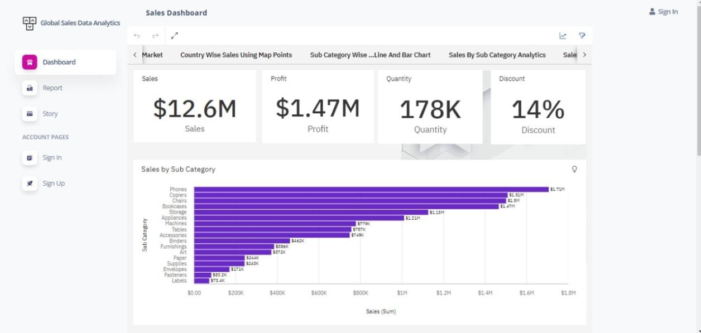

**Feature 2 - Embedding report to web app:**

<iframe

src=[https://us3.ca.analytics.ibm.com/bi/?pathRef=.my_folders%2FDa ta%2BModule%2FSales%2BReport&amp;closeWindowOnLastView=true&amp;u i_appbar=false&amp;ui_navbar=false&amp;shareMode=embedded&amp;act ion=edit](https://us3.ca.analytics.ibm.com/bi/?pathRef=.my_folders%2FData%2BModule%2FSales%2BReport&amp;closeWindowOnLastView=true&amp;ui_appbar=false&amp;ui_navbar=false&amp;shareMode=embedded&amp;action=edit) width=”1200” height=”600” frameborder=”0” gesture=”media” allow=”encrypted-media” allowfullscreen=””></iframe>

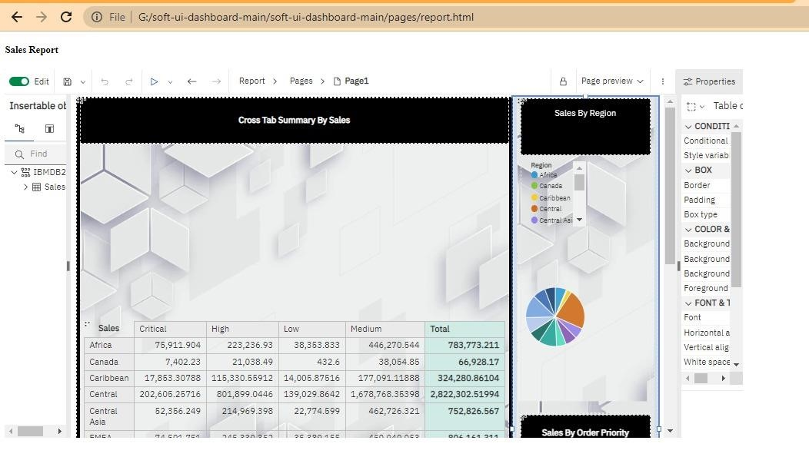

**Feature 3 - Embedding story to web app:**

<iframe src=[https://us3.ca.analytics.ibm.com/bi/?perspective=story&amp;pa thRef=.my_folders%2FData%2BModule%2FSales%2BStory&amp;closeWindow OnLastView=true&amp;ui_appbar=false&amp;ui_navbar=false&amp;share Mode=embedded&amp;action=view&amp;sceneId=model0000018485276975_0 0000000&amp;sceneTime=0](https://us3.ca.analytics.ibm.com/bi/?perspective=story&amp;pathRef=.my_folders%2FData%2BModule%2FSales%2BStory&amp;closeWindowOnLastView=true&amp;ui_appbar=false&amp;ui_navbar=false&amp;shareMode=embedded&amp;action=view&amp;sceneId=model0000018485276975_00000000&amp;sceneTime=0) width=”1300” height=”900” frameborder=”0” gesture=”media” allow=”encrypted-media” allowfullscreen=””></iframe>

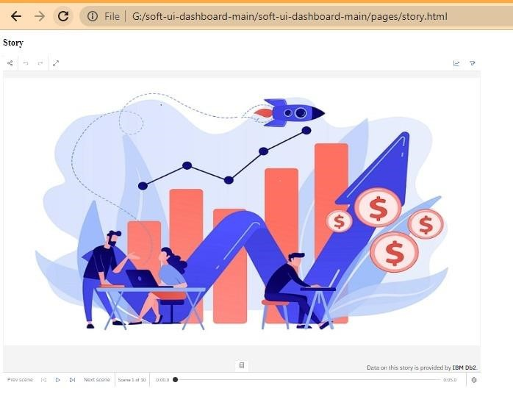

## 8. TESTING

### 8.1 Test Cases

**Test Scenarios**

* Verify user able to see login page
* Verify user able to login to application or not?
* Verify user able to navigate to create your account page?
* Verify user able to recovery password
* Verify login page elements

**Access visualizations**

* User able to see dashboard
* User able to see report
* User able to see stories

### 8.2 User Acceptance Testing

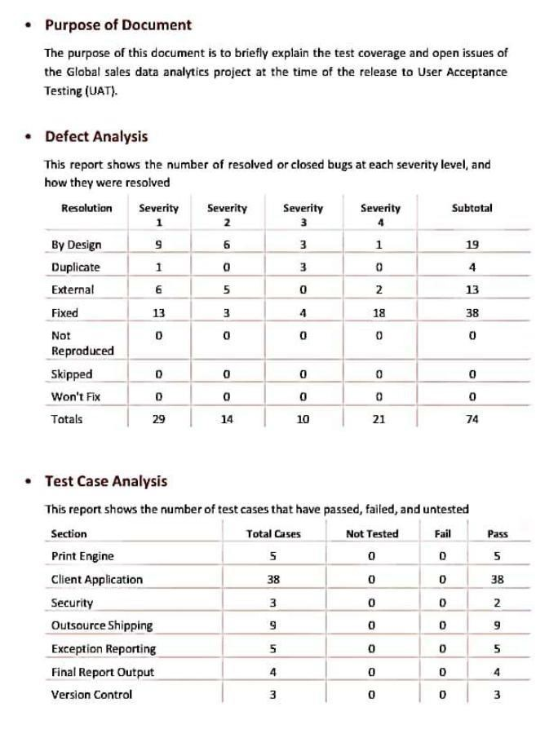

**8.3 MODEL PERFORMANCE TESTING**

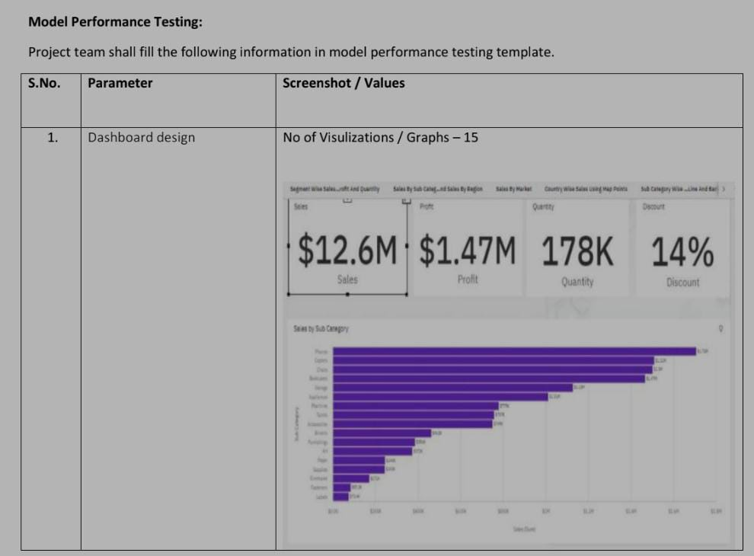

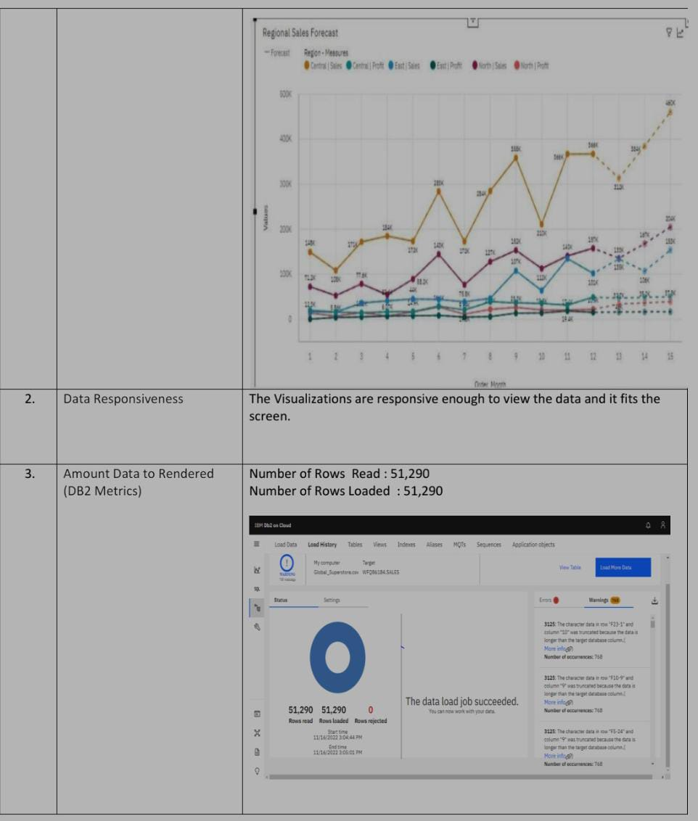

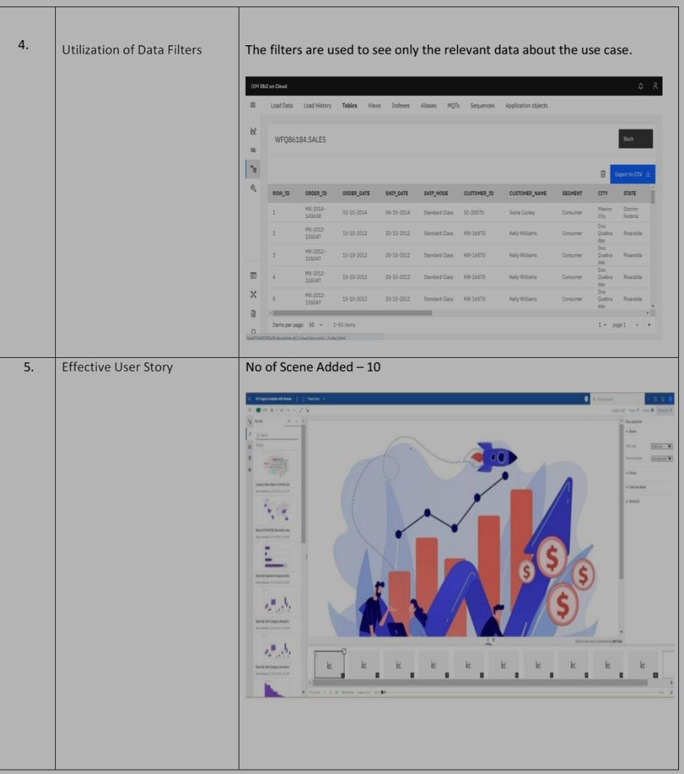

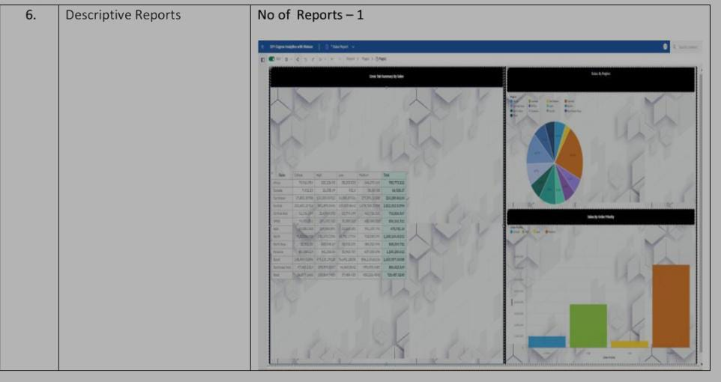

**9. RESULTS**

**Screenshots of web application:**

DASHBOARD:



REPORT:



STORY:



## 10. ADVANTAGES & DISADVANTAGES

**Advantages:**

* It is used to identify, optimize, and forecast sales.
* Sales data will help a company to take a future decision in terms of inventory management, marketing activities, schemes or offers to be rolled and changes in manufacturing processes if applicable.
* An efficient sales model that generates higher revenue for the business.
* Better prediction, Profit function performance.
* Helps to review their strategies and performance in order to make improvements.

**Disadvantages:**

* Sales pattern can be changed
* insufficient data may lead to wrong path.
* data may have been collected for historical reasons may not be suitable to answer the questions that we ask today.
* business users do not see results immediately

## 11. CONCLUSION

Analyzing sales helps businesses in understanding their most profitable products and the ones that are not moving, most profitable customers, and potential sales opportunities thereby providing sales which match customer needs and meets their satisfaction. An efficient sales model that generates higher revenue for the business. It helps in the perception of profit about particular product and perception of sales in different locations and times.

## 12. FUTURE SCOPE

Use the technology to collect and use sales data to derive actionable insights. It is used to identify, optimize, and forecast sales. An efficient sales model that generates higher revenue for the business. An efficient sales model that generates higher revenue for the business.

## 13. APPENDIX 13.1 Source Code

**kaggle api to gather the dataset**

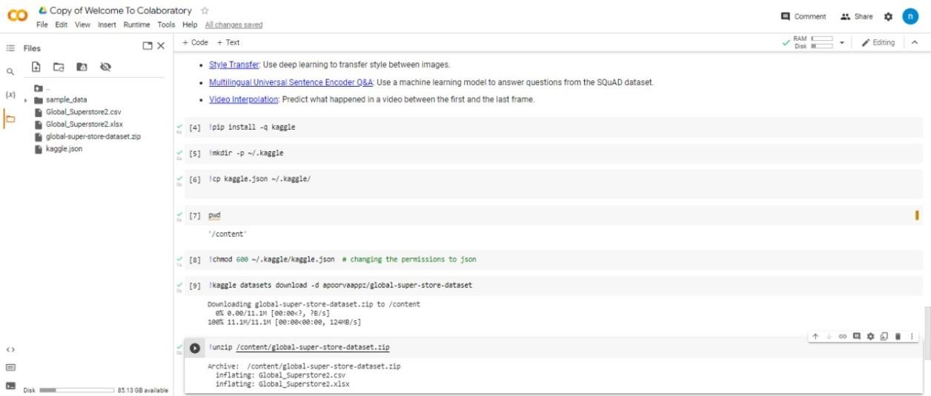

**13.2 Github & Project Demo Link:**

**GitHub:**

Link:  [h](https://github.com/IBM-EPBL/IBM-Project-41948-1660646436)ttps://github.com/IBM-EPBL/IBM-Project-24520-1659944133

Demo link:

https://drive.google.com/file/d/1xDtnXitSVxhdXp0pbuZ_ksf24nYQaal3/view?usp=sharing

**79**